Discussion (D)
Conjunction of argumentative exchanges referring to the same controversial issue
Argumentative exchange(s) (AE)
Series of interrelated argumentative moves referring to the same “sub-issue”, e.g. “Is fact F right or wrong?” or “Is aspect A relevant to the discussion?”
macro
level

Argumentative move(s) (AM)
Single argumentative speech act(s)
e.g. argument, disagreement
Move sequence(s) (MS)
Sequences of two argumentative moves, e.g. argument → disagreement
meso
level
micro
level
MS₁

MS...

AM₁

AM...
AM₂

MS₂

D

AE₁

AE₂

AE₃

AE…

…

…

…

W i d t h

D e p t h

Figure 1: Structure and levels of analysis of controversial discussions (modified version, Kienpointer, 1983)

Externalization

Initiating a new line of reasoning (reason-position-link)

Opposition

Formulating objections to an externalized argument

Reply

Responding to opposition to an externalized argument

Figure 2: Process of argument reappraisal (modified version, Leitão, 2000)

Inner circle (fishbowl):
active discussants
Observers with assigned contra standpoint

pro

pro
contra
table

contra
Outer circle:
observers of discussion
Observers with assigned pro standpoint

Figure 3: Seating arrangement (fishbowl discussion)

Externalization
Initiating a new line of reasoning:

- Externalized argument (Reason-position link)

Opposition
Formulating objections:

- Disagreement
- Counterargument
- Rebuttal
Thread level 1
Thread level 2 upwards
Thread level 3 upwards
Thread level 2 upwards
Support (co-construction)
Providing additional support:

- Agreement
- Continuation
- Elaboration
Reply
Responding to opposition:

- Integrative Reply
- Opposition to opposition
- (Concession and withdrawal)

Figure 4: Process of argument reappraisal in competitive discussions with assigned standpoints (modified version, Leitão, 2000)

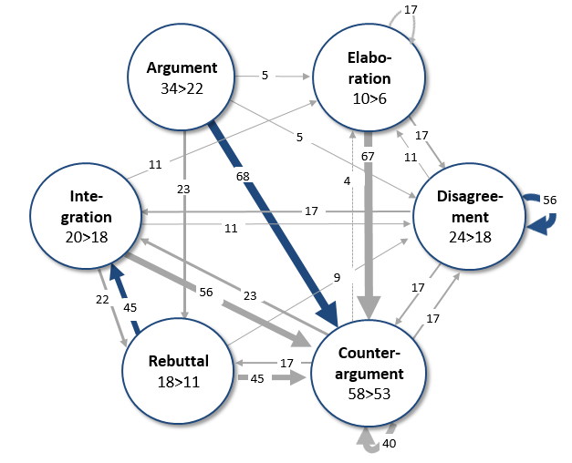

class A
class B
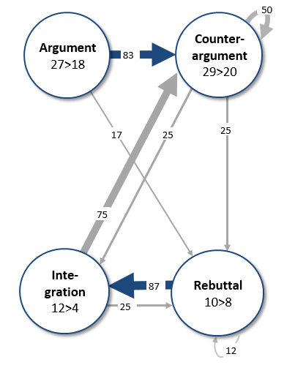
class D
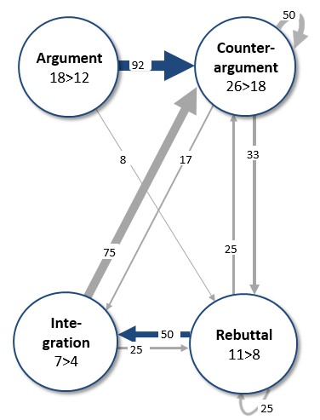

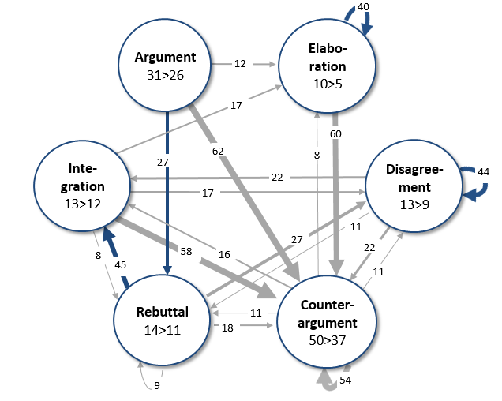

class C

Figure 5: Transitional State Diagrams (class A-D)
Annotations: The circles denote the argumentative moves. The values in the circles show the number of given moves of the respective move category and the number of replies, e.g. in class A 34 externalized arguments elicited 22 replies. The values on the arrows are transitional probabilities, e.g. in class A an externalized argument was followed by 68 % transitional probability by counterargument). The width of the arrows between moves represents the strength of the transitional probabilities. Moves with an absolute frequency smaller than five per class were not included in the diagrams (see table 2). Blue arrows indicate transitional probabilities that were significantly higher than the expected probability (z-score > 1.97, alpha < 0.05). Transitional probabilities were computed using the Discussion Analysis Tool (DAT) (Jeong, 2005).

class C
class D

Figure 6: Distribution of discourse modes by argumentative exchanges (class A-D)
Annotations: Discourse mode was assigned if at least one argumentative move of the respective discourse mode category is included in the argumentative exchange.

