Figure 1. Freedom on the Internet (0 best, 100 worst)
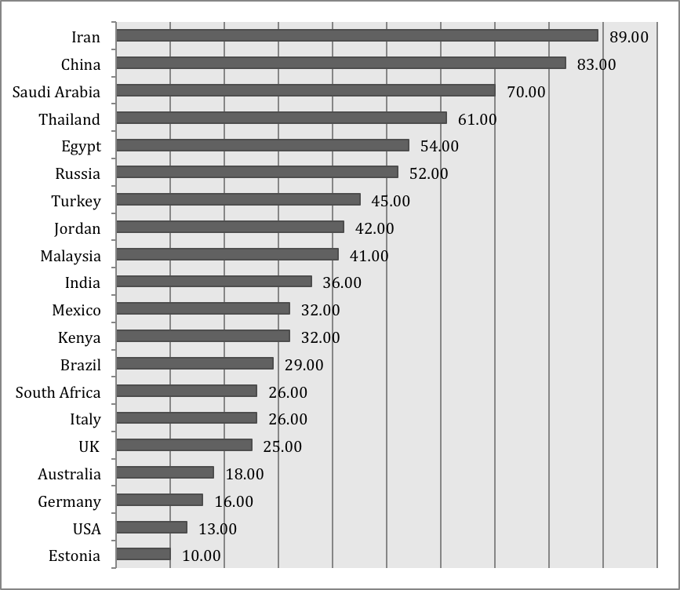
Source: “Kelly & Cook, 2011. Freedom on the Net: A Global Assessment of Internet and Digital Media.

Figure 2: Internet Filtering In Iran

Filtering | No evidence of filtering | Suspected filtering | Selective filtering | Substantial filtering | Pervasive filtering
Political |  |  |  |  | ◆
Social |  |  |  |  | ◆
Conflict/Security |  |  |  | ◆
Internet tools |  |  |  |  | ◆
Country Profile. 2009. Iran, OpenNet Initiative, (http://opennet.net/research/profiles/iran)

Figure 3: Internet Filtering In Egypt

Filtering | No evidence of filtering | Suspected filtering | Selective filtering | Substantial filtering | Pervasive filtering
Political | ◆
Social | ◆
Conflict/Security | ◆
Internet tools | ◆
Country Profile. 2009. Egypt,” OpenNet Initiative, (http://opennet.net/research/profiles/egypt).

Picture 1 Picture 2
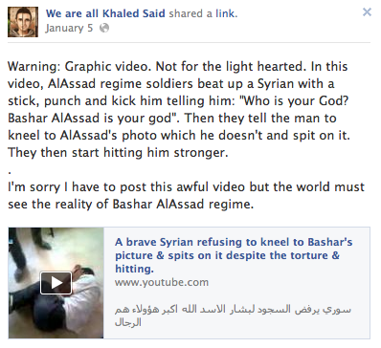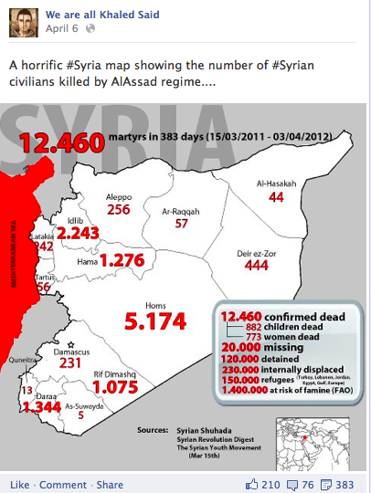

Source: We are all Khaled Said. (2012, January 5). Retrieved from https://www.facebook.com/elshaheeed.co.uk

Source: We are all Khaled Said. (2012, April 6). Retrieved from https://www.facebook.com/elshaheeed.co.uk

